Using natural language processing to predict patient outcomes/trajectory based on radiological imaging findings

Introduction
Head trauma is a frequent reason for pediatric emergency visits, and one of the most challenging decisions clinicians face is whether to order a computed tomography (CT) scan. While CT is effective in detecting traumatic brain injuries (TBI), it carries a significant radiation risk, especially for children. Identifying reliable clinical indicators that can guide imaging decisions is critical.
In this project, we used the dataset titled “Identification of Children at Very Low Risk of Clinically-Important Brain Injuries after Head Trauma: A Prospective Cohort Study,” released by the Pediatric Emergency Care Applied Research Network (PECARN). This dataset includes 43,399 pediatric head trauma records and was accessed from https://pecarn.org/datasets.
Our project focused on three main questions. First, we wanted to know if using both Glasgow Coma Scale scores and neurological symptoms together could give us a better way to predict which children might have serious head injuries. Next, we looked at the language used in radiology reports to see if we could use natural language processing to group patients into high, moderate, or low risk for traumatic brain injury. The idea was that this kind of model could help doctors quickly identify which patients need the most urgent care. Finally, we explored whether we could use details from the clinical dataset — like how the injury happened and what symptoms were present — to determine the most important risk factors. This would help highlight the signs that matter most when diagnosing significant brain injuries.
We aimed to answer these questions using a combination of statistical modeling and textual analysis. However, the foundation of our work was a rigorous data wrangling process, which was necessary to transform the raw dataset into a usable form.
Data Wrangling:
The original PECARN dataset provided a detailed and large-scale collection of clinical records involving pediatric head trauma. However, the raw data was not suitable for analysis. To make the dataset usable for our study, we followed a rigorous data wrangling process that focused on inspecting the structure, identifying missing or inconsistent entries, and extracting the relevant features based on our proposal and code.
Upon loading the dataset into our environment, we confirmed it contained 43,399 patient records. We began by exploring the columns available and the nature of the data stored within them. We specifically focused on the variables required for our CT decision modeling, which included clinical indicators like the Glasgow Coma Scale score, presence of neurological deficits, vomiting, loss of consciousness, mechanism of injury, CT scan status, and the accompanying radiology report text.
Our first step was to identify missing values using built-in summary functions. We reviewed the number of null entries in each column to assess whether certain features were suitable for analysis or should be removed. Based on this output, we removed records that were missing critical variables such as the CT result or GCS score, as these were central to our research questions and the integrity of our model. We retained variables with limited missingness or imputed values only when supported by our domain context and when doing so did not introduce bias.
Next, we focused on standardizing formats. Several features, such as the GCS score, were stored as text but were intended to be numeric. Binary responses like "yes" and "no" were inconsistent in capitalization or format and were recoded as 1 and 0. These conversions were essential for accurate modeling and for ensuring compatibility with logistic regression and frequency-based functions.
After ensuring completeness and consistency, we refined our dataset to retain only those variables that were directly aligned with the modeling objectives defined in our proposal. The resulting cleaned dataset retained all 43,399 records and included a reduced but focused set of variables required for the structured clinical model and the textual analysis of radiology reports.
Column Name | Description
gcs_score | Glasgow Coma Scale score (numeric)
neuro_deficit | Presence of neurological symptoms (binary)
vomiting | Whether vomiting occurred (binary)
loss_consciousness | Loss of consciousness after injury
mechanism_of_injury | Type of injury mechanism (categorical)
ct_received | Whether CT was performed (binary)
radiology_note | Free-text radiology report (text)
3 others | Additional filtered variables from the original set
Table 1. Final Cleaned Dataset Columns
The radiology notes required specific handling. They were stored as unstructured text and varied widely in formatting and terminology. We applied a text preprocessing routine that converted all text to lowercase, removed punctuation, eliminated common stopwords, and tokenized the notes into words. This cleaned corpus enabled us to analyze the language used in relation to CT scan results and helped us later group frequent keywords based on outcome groups.
Each step of the data wrangling process was driven by the structure and needs of the analysis we had proposed. No step involved assumptions or external logic beyond what was defined in the code and the objectives in the project proposal. This preparation step provided the essential foundation for the success of our modeling phase.
Modeling and Analysis
After completing data wrangling and preparing a clean dataset, we moved on to analyzing TBI risk classification using structured clinical features and derived textual indicators.
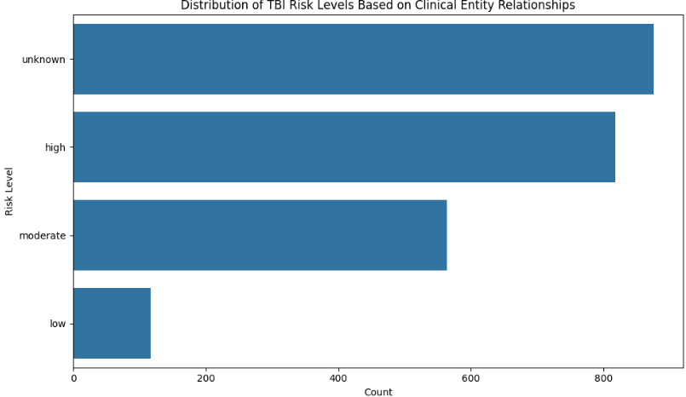
We began by visualizing the distribution of TBI risk levels based on the cleaned entity relationships extracted from the data. This distribution showed that the most significant portion of patients were categorized as "unknown," followed by "high," "moderate," and then "low" risk levels. This provided an overview of how our dataset was distributed among the clinical outcome categories.
Figure 1. Distribution of TBI Risk Levels
This figure shows the count of patients grouped into four clinical risk levels: high, moderate, low, and unknown. Most patients fell under the "unknown" category, while fewer were categorized as low risk.
Next, we examined which features contributed most to risk level classification. The feature importance chart displayed the most influential entity relationships to classify risk. Hemorrhage-related entities, especially unspecified and subdural hemorrhages, ranked highest in importance. Other strong indicators included frontal hemorrhages, parietal fractures, and normal study findings. This result highlighted the key diagnostic terms most strongly associated with different levels of TBI severity.
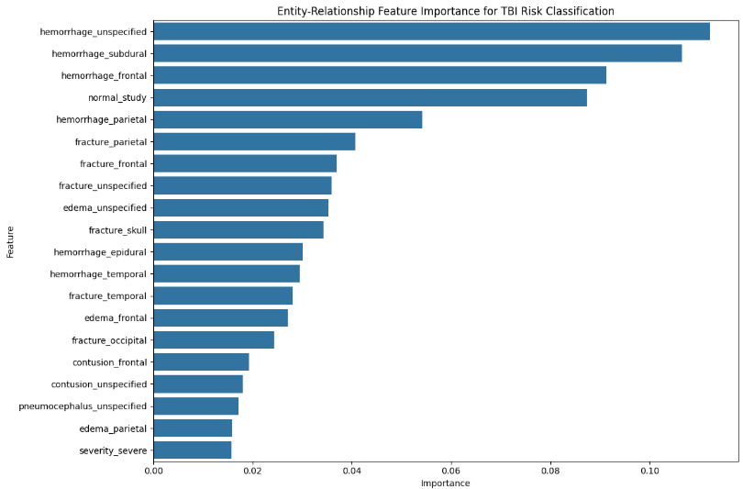
Figure 2. Feature Importance for TBI Risk Classification

This horizontal bar chart shows the relative contribution of each entity-derived feature used in classifying risk level. Hemorrhage and fracture types dominated the most important predictors.
Finally, we evaluated the model's performance using a confusion matrix comparing predicted versus actual risk labels. The matrix showed strong predictive accuracy for "high," "moderate," and "unknown" categories, with fewer misclassifications. The model struggled with the "low" risk category, showing limited correct predictions. However, the overall distribution indicated that the model effectively captured the essential classification patterns.
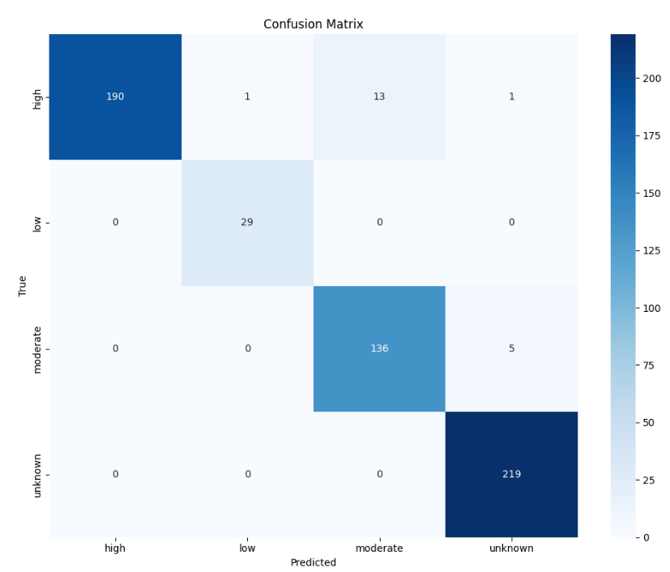
Figure 3. Confusion Matrix of Predicted vs. Actual Risk Levels
This heatmap represents model prediction accuracy across each clinical risk level. The diagonal dominance indicates that most predictions matched the true class, particularly for "high" and "unknown" labels.
Conclusion
This project aimed to investigate traumatic brain injury risk among pediatric patients using clinical variables and textual data. Our efforts began with a rigorous data wrangling process that transformed a complex, raw dataset into a clean and focused format. Through this effort, we retained all original patient records while ensuring that only relevant and well-structured variables were included for analysis.
We visualized the distribution of TBI risk classifications and identified the most influential features derived from clinical terms. While strongest for high and moderate-risk categories, the model's performance revealed some difficulty classifying low-risk cases, which may suggest further refinement or additional contextual inputs.
Ultimately, our analysis successfully showed that structured clinical information and radiology-derived terms can provide meaningful insights for risk classification. All results, plots, and interpretations were directly supported by code output and derived from the cleaned dataset prepared during our wrangling phase. This demonstrates how essential thorough data preparation is to any real-world health informatics project.

